Assignment 5

1. Write a function to compute 5/0 and use try/except to catch the exceptions.

**Code**

def Throw_Err():

return 5/0

try:

Throw_Err()

except ZeroDivisionError:

print ("division by zero!")

except Exception:

print ("Caught an exception")

finally:

print("In finally block for cleanup")

**Screenshot:**

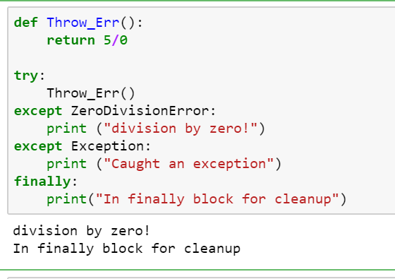

|  |
| --- |
|  |
|  |  |
|  |  |
|  |  |
|  |  |

2. Implement a Python program to generate all sentences where subject is in ["Americans",

"Indians"] and verb is in ["Play", "watch"] and the object is in ["Baseball","cricket"].

Hint: Subject,Verb and Object should be declared in the program as shown below.

subjects=["Americans ","Indians"]

verbs=["play","watch"]

objects=["Baseball","Cricket"]

Output should come as below:

Americans play Baseball.

Americans play Cricket.

Americans watch Baseball.

Americans watch Cricket.

Indians play Baseball.

Indians play Cricket.

Indians watch Baseball.

Indians watch Cricket.

**Code**

subjects=["Americans", "Indians"]

verbs=["Play", "Watch"]

objects=["Baseball","Cricket"]

for i in range(len(subjects)):

for j in range(len(verbs)):

for k in range(len(objects)):

sentence = "%s %s %s." % (subjects[i], verbs[j], objects[k])

print(sentence)

**Screenshot:**

